Prep/Foundation
Enrolments
2023
School Tours Wednesdays 9.15am

E-mail or phone to book a tour.
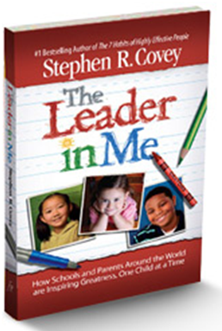
77 Argus Street Cheltenham 9583 8342 le.page.ps@education.vic.gov.au
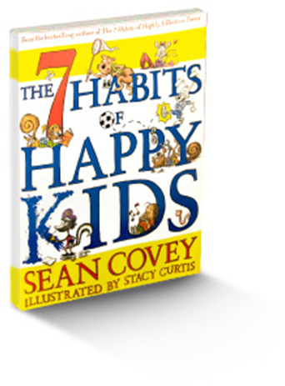

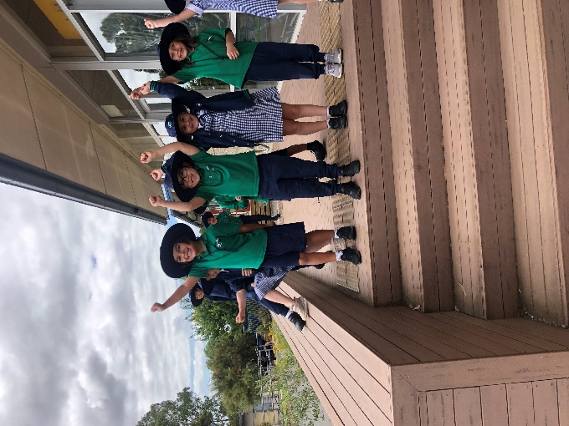

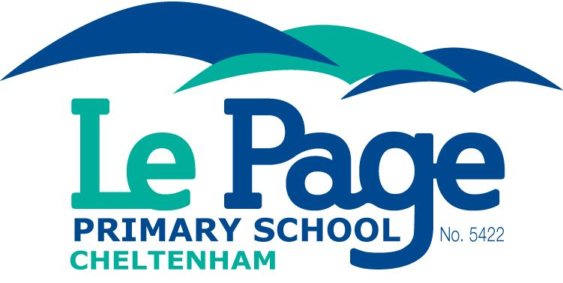

Vision
There is a prosperous path for every child.
Each journey is theirs to lead.
There is a place, in which every child can shine.

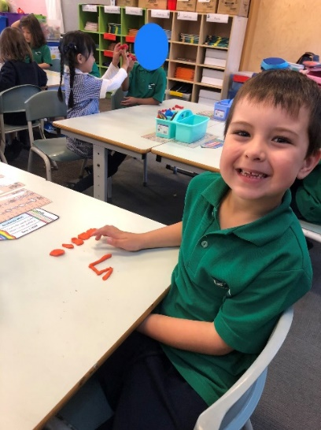

Mission Identify the talent.
Develop the confidence. Create the leader.

Attitude

Be grateful for what I have.
Practice random acts of kindness.
Keep in the present moment.
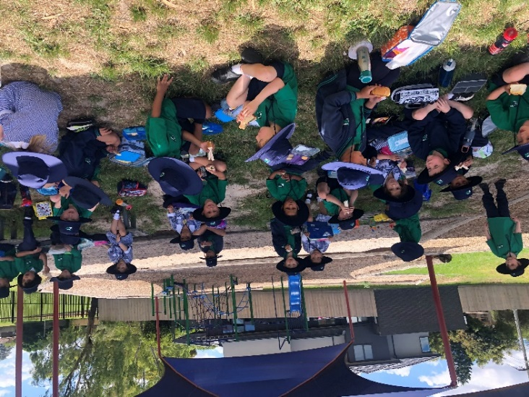

Transition Program
Teachers and students will build relationships in preparation for 2023.
Booking vis email le.page.ps@education.vic.gov.au or (03) 9583 8342

Foundation Open Sessions –
10.00-11.00am – Parent Stay, Chat and Play
Mar 31, May 12, June 3, June 22

Stay and Play Sessions
Student can be dropped off
Wednesdays 9:30-10:30am
July 27, Aug 17, Sep 7,

Fridays 9:30-10:30am
Oct 28, Nov 11, Nov 25,

Parent Information Session
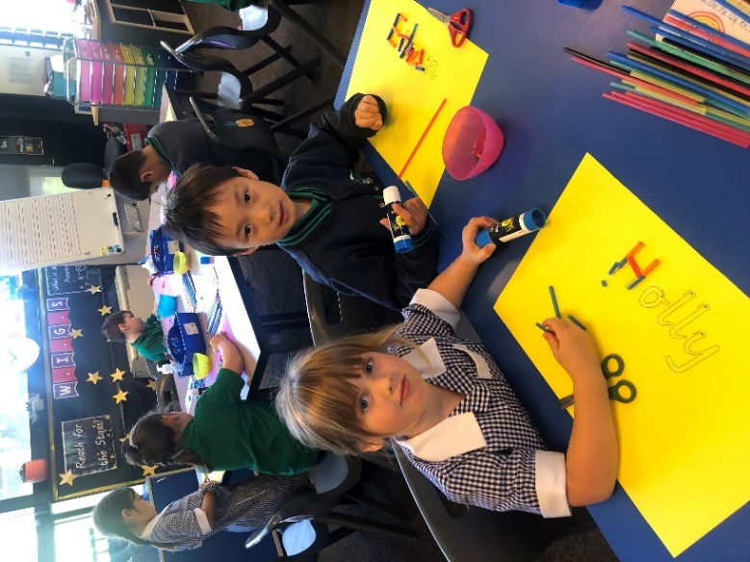
Monday December 5th 6-7pm
School programs, uniform, booklists, and school fees will be the focus of this session.

Enrolment Details
Enrolment documents may be collected from the school office or downloaded from the school’s website.

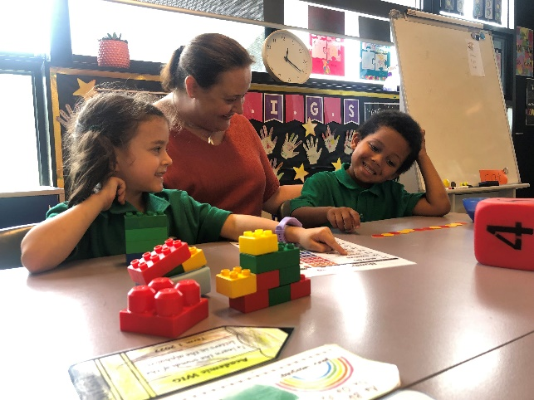
Performing Arts
Students participate in weekly music classes with a focus on guitar, keyboard, percussion, recorder and singing.

Scholarships
Vocal & Strings
Orchestral Program

Each child
has a gift or talent.
It is our job to find it and to show it to them.

[Sidebar Title]

The 7 Habits of Highly Effective People
Teachers have been trained to demonstrate the Habits and to develop them in the children. The Leader in Me process is the framework used for developing common proactive language, a positive growth-mindset and happy students.

Leadership Notebooks
Students set goals, develop achievement plans, monitor progress and celebrate success. Student-led conferences provide students the opportunity to articulate how they set goals, make plans, monitor progress and get results.

Come see, hear and feel the difference.
Leadership

