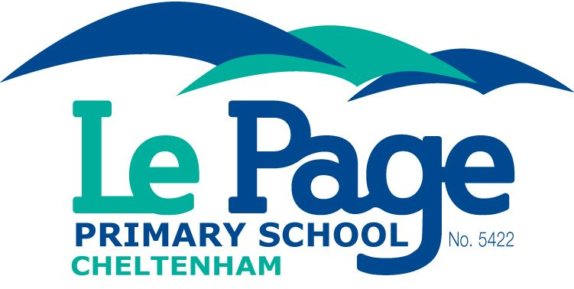
Prep/Foundation
Enrolments
2021
School Tours Weds 9.15am & 6pm

E-mail or phone to book a school tour.
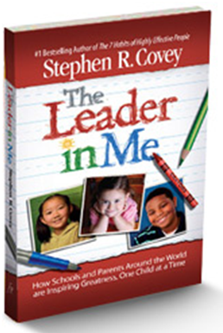
77 Argus Street Cheltenham 9583 8342 le.page.ps@edumail.vic.gov.au
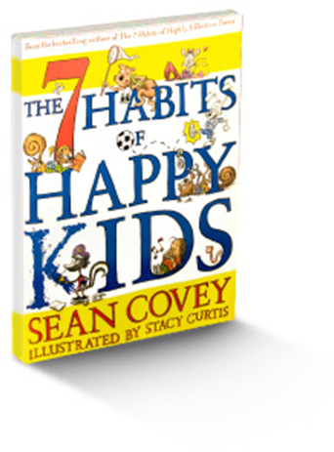

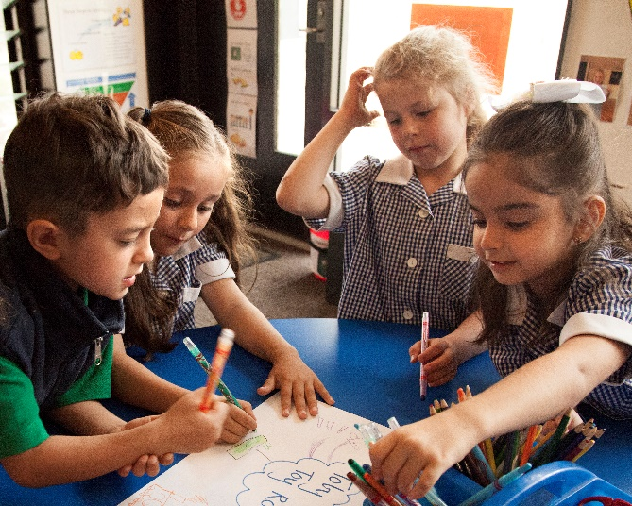

Vision
There is a prosperous path for every child.
Each journey is theirs to lead.
There is a place, in which every child can shine.

Mission Identify the talent.
Develop the confidence. Create the leader.

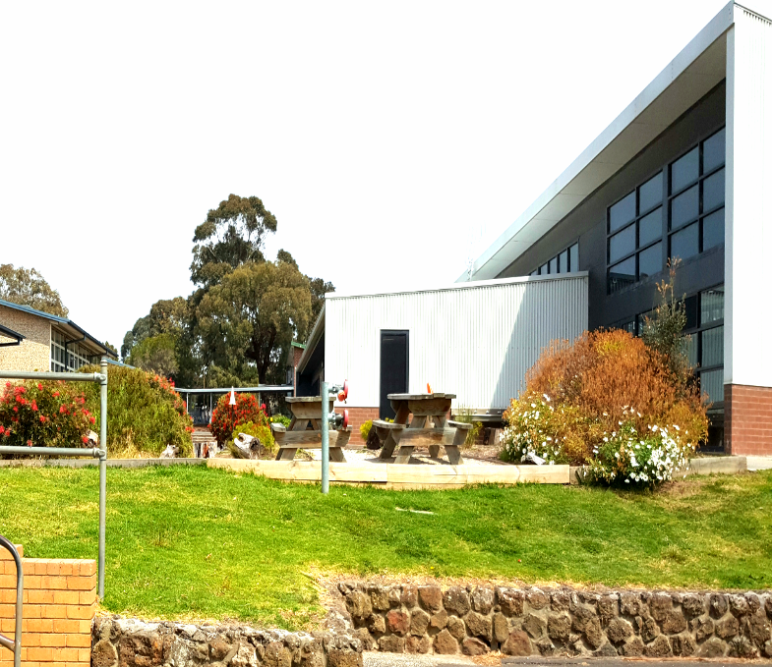
Attitude

Be grateful for what I have.
Practice random acts of kindness.
Keep in the present moment.

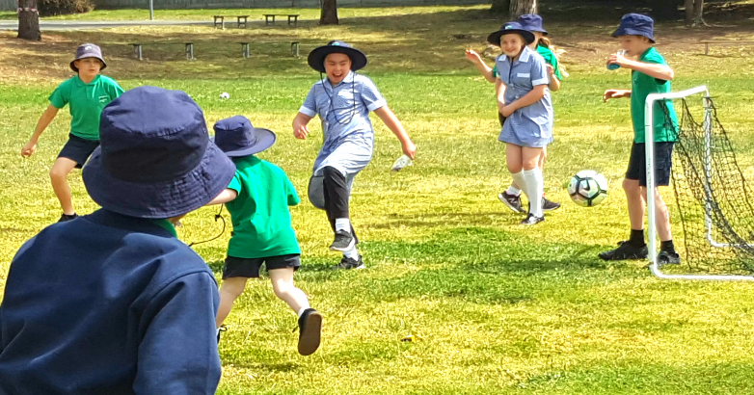

Classroom Transition Program
Teachers and students will build relationships in preparation for 2021.

Fridays 9:30-10:30am
Apr 17, May 15, Jun 19, Jul 17, Aug 14, Nov 27

Friday December 4th 9:30-12:30pm
The three-hour session provides a regular half-day experience including recess and lunch.

In term 4, parents may extend the transition process by hours or half/full days, to cater for their children’s individual needs.

Parent Information Session
Monday December 7th 6-7pm
School programs, uniform, booklists and school fees will be the focus of this session.

Enrolment Details
Enrolment documents may be collected from the school office or downloaded from the school’s website.

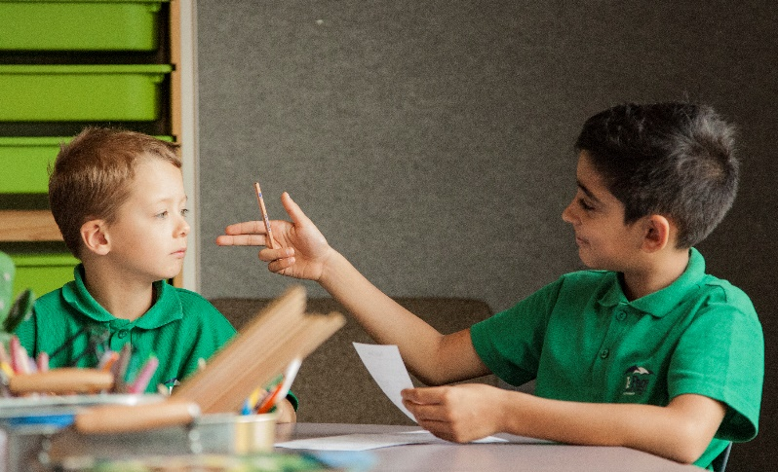

The 7 Habits of Highly Effective People
Teacher have been trained to demonstrate the Habits and to develop them in the children. The Leader in Me process is the framework used for developing common proactive language, a positive growth-mindset and happy students.

Leadership Notebooks
Students set goals, develop achievement plans, monitor progress and celebrate success. Student-led conferences provide students the opportunity to articulate how they set goals, make plans, monitor progress and get results.

Come see, hear and feel the difference.

Leadership

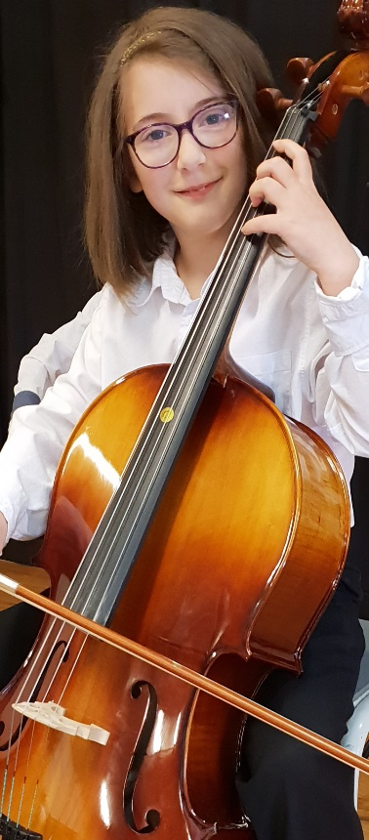
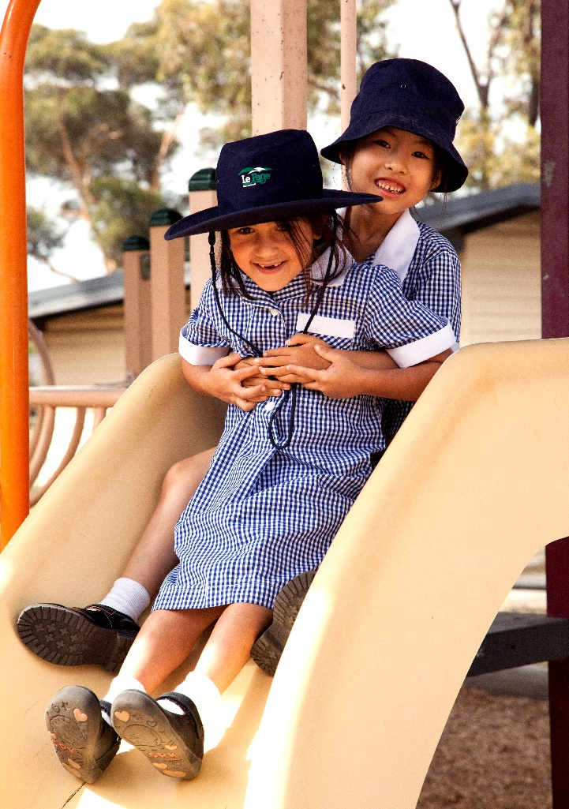
Performing Arts
Students participate in weekly music classes with a focus on guitar, keyboard, percussion, recorder and singing.

Scholarships
Vocal & Strings
Orchestral Program

Each child
has a gift or talent.
It is our job to find it and to show it to them.

[Sidebar Title]

